## NAME: AKACHI IKWU

## SUBJECT: SIT103

## STUDENT_ID: 221320482

* 1. ABOUT THE COMPANY

**VADEN SPECIALIST CLINIC AND FERTILITY CENTRE** is the best specialist clinic in Owerri, Imo State ,Nigeria. This clinic is owned by the present Commissioner for Health by name Dr. Okorochukwu. VADEN SPECIALIST CLINIC website address is not available but Vaden clinic has a Facebook account[**@vadenspecialistclinic**](mailto:@vadenspecialistclinic)**.** This clinic as the name goes VADEN SPECIALIST CLINIC AND FERTILITY business/concern is mostly for women having any type of issue at all especially women finding it difficult to conceive. There are also some pediatricians and physician Doctors that attend to the children and the few men that comes to the clinic. VADEN CLINIC is located at ***4b Solid Rock Road, off World Bank, Owerri, Imo State, Nigeria***. Vaden Clinic has two buildings in the same location. ( Vaden clinic has no branch) One building (two storey building) is where the Laparoscopic Surgeries are only done because they machines used for it cannot be transferred to the new building. The new building (three storey building) is where other services are done. Apart from the services that clinics are mostly known for, Vaden Specialist Clinic and Maternity offer additional services which are:

1. ***ENDOSCOPIC SURGERIES***

***(Pin Hole Surgeries)***

* ***Laparoscopy***
* ***Hysteroscopy***

1. ***ASSITED REPRODUCTIVE TECHNIQUES (ART)***

* ***IUI- Intra Uterine Insemination***
* ***IVF- In-Vitro Fertilization***
* ***ICSI- Intra Cytoplasmic Sperm Injection***

Like I said earlier, the clinic is owned by the present Commissioner for Health in Imo State with some services including the Scan section, the Laboratory, the Dispensary and all they Doctors that work there are all Consultants in their area of specialization. Vaden Clinic has approximately 150 employees.

**Two General Physicians,**

**Five Gynecologists,**

**Three Pediatricians**

**One Radiologist**

**Two Urologists**

**50 Nurses**

**And the others are non-medical Staffs’.**

The mission and vision of this clinic:

**Mission**

To provide special and affordable health care services across the various state of our society.

**Vision**

To ensure we remain at the apex of health care services by imbibing modern health care Technologies as they evolve.

**Stakeholders**: The Chief Medical Doctor (CMD), Medical Director(MD), General Manager (GM), Assistant General Manager/Human Resources (HR), Head, Nursing Services (NHS), H.O.D Pharmacy, H.O.D Laboratory Services, H.O.D Accounts and H.O.D Health/Medical Records.

In Vaden Clinic, universities students studying Nursing comes to the Clinic for experience/training.

The clinic is competing with so many clinics but to mention few:

Eastern Summit Specialist Clinic and Maternity with website address: <https://easternsummitspecialistclinicandmaternity.business.site>

Life Gate clinic: no website available.

St. Elizabeth Clinic[: stelizabethfertilityspecialists.com](stelizabethfertilityspecialists.com)

1.2 Business Scenario

VADEN SPECIALIST CLINIC AND MATERNITY has two buildings in only one branch. One building for Laparoscopic Surgery and the other building is the main building.

Vaden Specialist offers services related to health and other services which I mentioned in 1.1 which is located in Owerri, Imo State, Nigeria. They have:

The Laboratory,

The scan section,

Dispensary.

When a new patient comes into the clinic, he/she must go to the reception desk where their file is open or their child’s file is open and the patient is given a small hospital card which the patient must carry to the hospital for easy access to his/ her file which will be taken to the Doctor for his/her choice. If the Doctor of your choice is not available at the moment or will not be coming that day despite it being one of the days he comes to the hospital, one of the receptionist announces it with a microphone calling the Doctors name and when next he will be available and also mentioning the available Doctors and their specialization in case you want to make another choice or you can come back next time. After the patient goes to the reception to make payment then you seat while your file is given to the nurses recording the vital sign and weight check ( if you are only pregnant). When your name is called, you go for your vital sign checking. After the vital sign, the Nurse will ask you the Doctor you want to meet so she can add your name under the Doctor’s list. After that you go back to your seat and wait for your name to be called. When your name is called, you go to the second waiting room there, the Clinic’s staff will give you a number. After seeing the Doctor, a staff will go into the Doctor’s office, and take your file to either the Dispensary or the Scan section depending on the instruction. When your file is taken to the dispensary, you sit and wait for your name to be called while they check the drugs prescribed and record the total amount after which they call your name and give you a small piece of paper where the amount is written and you will take it to the Account Section and pay then go back to the Dispensary and hand over your receipt to them where your drug(s) will be issued to you. If you are directed by the Doctor to go to the Laboratory, your file is taken to the Laboratory where they take note of the test asked by the Doctor to conduct for you then the amount is written in a small piece of paper which you will take to the Account Section where you make payment and be given a receipt which you will take to the Lab and conduct the test then you will be told when next to come back and while coming you must come back with your receipt or your hospital card. If the Doctor directs you to the Radiologist, a staff takes your card to the Scan section after having your scan, your file is not given back to you after taking your scan records but is taken back to the Doctor or the Reception depending on if the Doctor has instructed to still see him that after the scan or come back next time. The owner of the clinic who is the Chief Medical Doctor (CMD) is the only one who has the right to reduce your surgery amount if surgery is needed. When your Doctor takes permission from him concerning the amount then the amount is written on the file and the Lab test required taking before the surgery is also written on your file then when that is done the Chief Medical Doctor and your Doctor will fix a date for your Surgery then a Staff will take your file to the Account Section where you make all your payment and be given a receipt. There Surgery is conducted by 5.30am so you are told to come a day before. Your file will also be taken to the Theater before the surgery starts. When you visit the clinic for only Scan or Lab test, you will be given amount to pay at the reception for only Scan but only the Lab attendant will write down the amount to pay for your test at the Laboratory. When there is an emergency, the security men carries the patient to the emergency ward then the person with the patient will open your file or give any details about the patient while they Doctors attend to the emergency patient. Vaden Clinic employees are paid monthly via their bank accounts. The clinic has no part time workers but full time workers.

The Doctors who work in another hospital have their days of work in Vaden Clinic and they are paid monthly for it but if for any reason a Doctor works other days excluded from his/her days , they are paid according to the number of patients they consult per day.

Business Rules ( Assumptions)

A Doctor can attend to many patients.

A patient is attended by one or many Doctor(s).

When a Doctor is not available, a patient can chose another Doctor.

The Chief Medical Doctor (CMD) decides the amount only for Surgeries.

The Chief Medical Doctor fix dates for your surgery.

When you pay to see the Doctor and the Doctor is not available, your payment is valid until after five days.

No receipt, no Lab test result.

If you lose your hospital card, you are given opportunity to look for your name if only you can remember the month you registered.

Without paying for consultation, you cannot see any Doctor.

Without getting a file, you cannot see any Doctor.

**REVIEWS OF VADEN CLINIC**

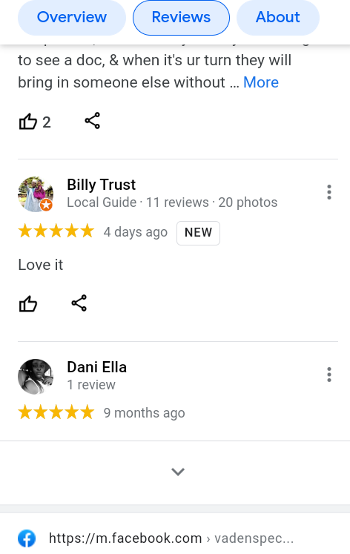

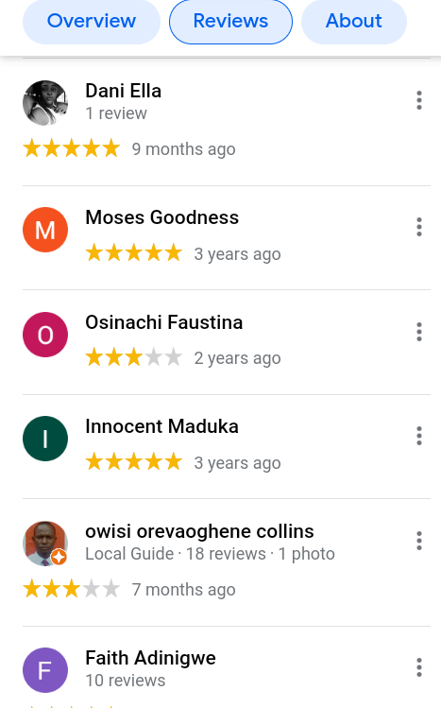



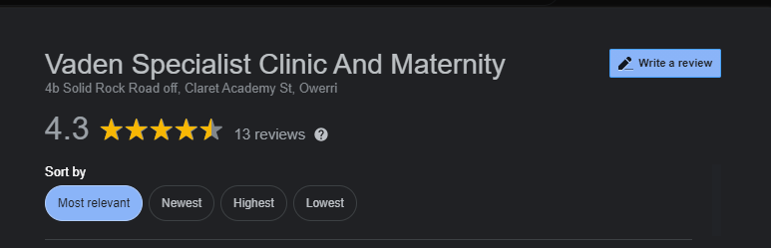

**EASTERN SUMMIT CLINIC REVIEW**

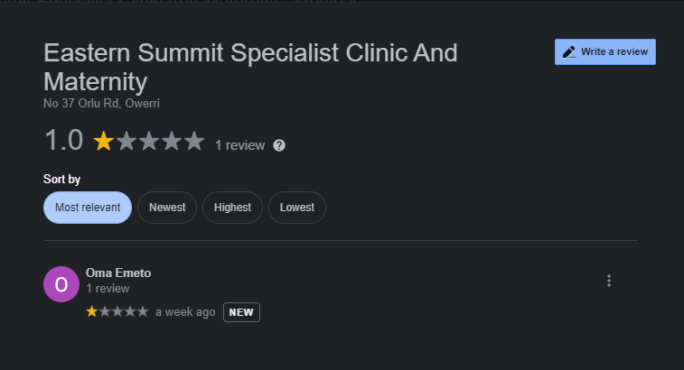

Eastern Summit clinic is another good clinic in Owerri, Imo State, Nigeria owned by a Gynecologist named Dr. Obiora. When a patient opens a file (registration) the patient is given a clinic card and waits to be called for vital sign after which he/she is called to meets the doctor or any other doctor available. The employees are paid monthly via their bank accounts.

**LIFE GATE CLINIC REVIEW**

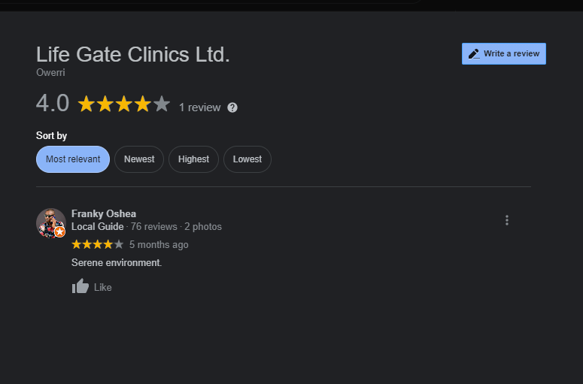

1.3 Context level data flow diagram

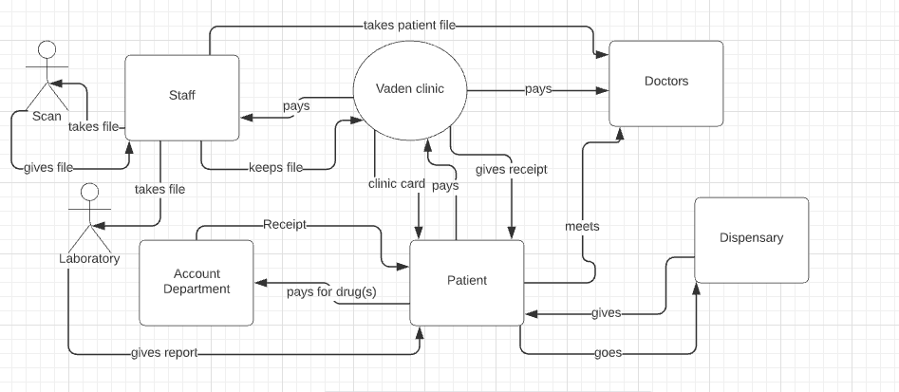

1.3b some input and output

**PATIENT FILE (input):** Patient Name, Patient Phone Number, Patient Address, Patient Next of Kin, and Relationship with Next of Kin

**RECEIPT (output):**  Receipt Number, Patient Name, Reason for Payment, Amount Paid, and Date.

**CLINIC CARD (output):**  Clinic Phone Number, Card Number, Patient Name, and Date.

**REFERENCE**

**<**[**https://web.facebook.com/vadenspecialistclinic/?_rdc=1&_rdr**](https://web.facebook.com/vadenspecialistclinic/?_rdc=1&_rdr)**>** accessed on25th September, 2021